User Manual for course Registration system

COMP2411 Homework#2

In a team of 2 students:

DENG Xindi 18081072d ZHAN Jing 18081127d

Table of Contents

1. Overview 2

1.1 Background 2

1.2 Developers (Description of each team member's work) 2

2. Running Environment 3

2.1 How to run the program 3

2.2 Data Used 3

3. Using the System 4

3.1 Login 4

3.1.1 Initial Login Interface 4

3.1.2 Student Login Interface 4

3.1.3 Administrator Login Interface 5

3.2 Student Interface 5

3.2.1 Initial Student Interface 5

3.2.2 List Courses Interface 6

3.2.3 List Registered Courses Interface 6

3.2.4 Register Courses Interface 7

3.2.5 Modify Personal Information Interface 7

3.3 Administrator Interface 8

3.3.1 View Functions 9

3.3.2 Modify Functions 10

3.3.3 Grade Functions 11

3.3.4 List Top5 Functions 14

**1. Overview**

**1.1 Background**

This program runs as a course registration system for both the students and the administrator.

Student can use this program to manipulate their personal information and register courses.

Administrator can use this program to manipulate the data stored in the database. Administrator can manipulate student, course and grade information.

**1.2 Developers (Description of each team member's work)**

There are two members in the team, DENG Xindi and ZHAN Jing, as stated at the cover page.

DENG is responsible for the GUI and SQL for question a, b, d, f, h, j, as well as the GUI for question l and m.

ZHAN is responsible for the GUI and SQL for c, e, g, I, k, as well as the SQL for question l and m.

**2. Running Environment**

**2.1 How to Run the Program**

Our code is consisted of 5 java files, Main.java, operation.java, Login.java, Administrator.java, Student.java .

To run the whole program, same as elaborated in the lab, put “ojdbc7.jar” and the 5 java files in the same folder, and type in “command” as follows:

*Javac -cp ojdbc7.jar Main.java operation.java Login.java Administrator.java Student.java*

Then type in:

*Java -cp ojdbc7.jar;. Main*

The Login Interface will pop up. Then you may use the system following the guide in Chapter ***3. Using the System*** (in the following contents).

**2.2 Data Used**

Three tables are involved for the assignment (e.g. Courses, Students, Enrollment).

Three tables are stored in the Oracle Database.

The data are the dataset given as “dataset.sql” file retrieved from the Blackboard.

**3. Using the System**

**3.1 Login** *( Question (a) )*

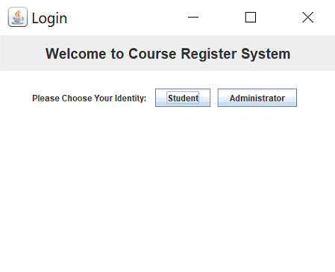**3.1.1 Initial** **Login Interface**

In the initial interface, you should first choose your login identity: Student or Administrator.

**3.1.2 Student Login Interface**

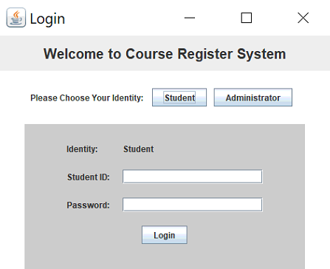

In this interface, you could login as Student. (Hint: the original Password is “12345678”)

**3.1.3 Administrator Login Interface**

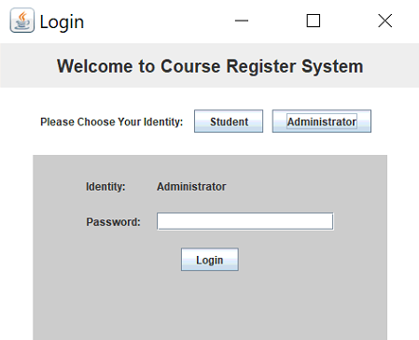

In this interface, you could login as Administrator. (Hint: the original Password is “87654321”)

**3.2 Student Interface**

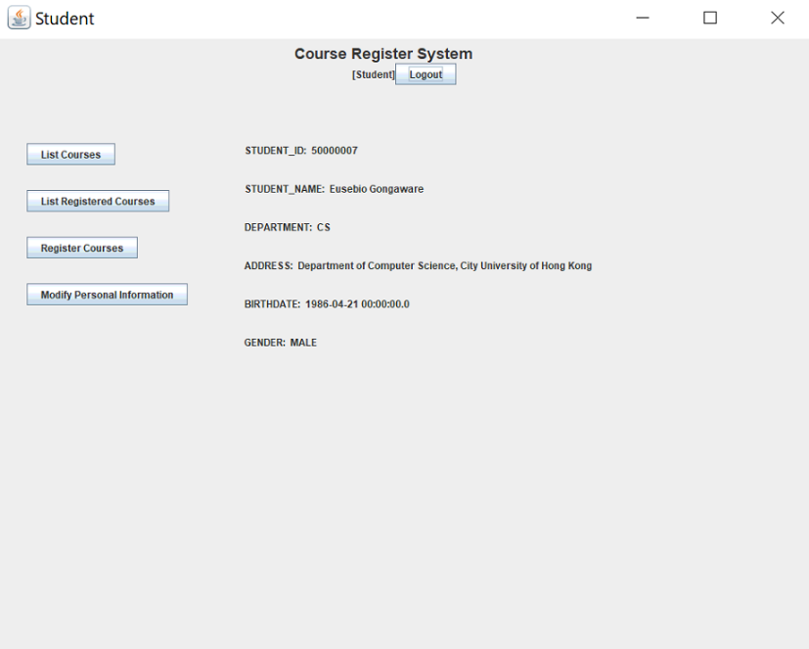**3.2.1 Initial Student Interface** *( Question (b) )*

In this interface, you can see your personal information first, and have five operation options:

1. Click **“Logout”** button, then you can logout the system.
2. Click **“List Courses”** button, to see the list of all the courses in the system.
3. Click **“List Registered Courses”** button, to see the list of all the courses that you have registered.
4. Click **“Register Courses”** button, to register courses in the system.
5. Click **“Modify Personal Information”** button, to modify your personal information.

*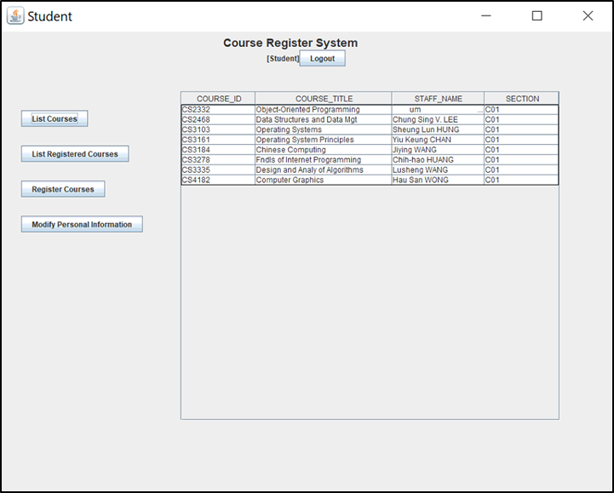***3.2.2 List Courses Interface** *( Question (b) )*

This table list all the courses in the system.

*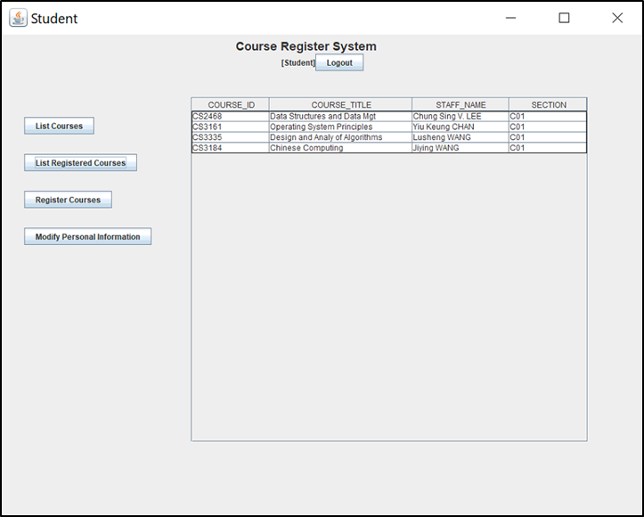***3.2.3 List Registered Courses Interface** *( Question (c) )*

This table list all the courses that you have registered.

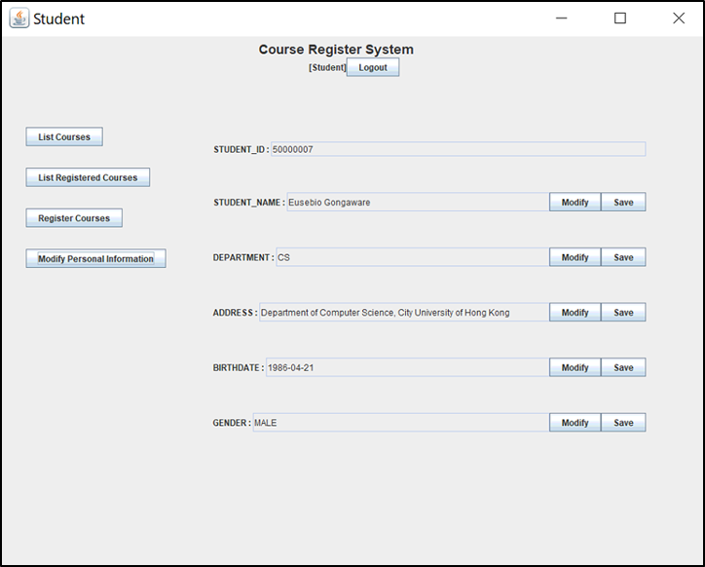**3.2.4 Register Courses Interface** *( Question (d) )*

This table list all the courses that you has not registered. Before you register, read the hint above the table first.

**3.2.5 Modify Personal Information Interface** *( Question (e) )*

In this interface, you could modify your Personal Information(except STUDENT_ID, which is unmodifiable).

If you want to modify the information, you should click **“Modify”** button first, then the corresponding text filed could be modifiable. After modifying, you should click **“Save”** button to save your modification.

**3.3 Administrator Interface**

This panel is for administrator to manipulate the course, student and enrollment data stored in the database.

The original view panel is as follows:

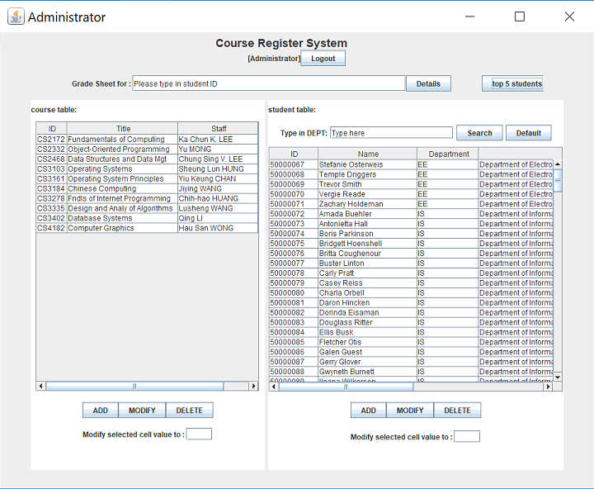

**3.3.1 View Functions**

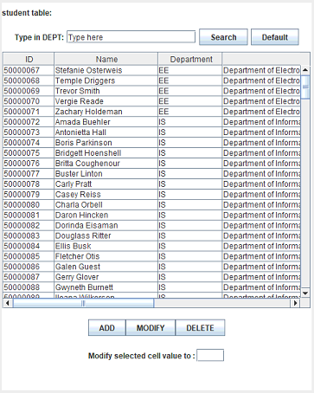1. The default view of the Administrator Panel lists all the courses and students stored in the system. The left table shows information of courses, and the right table shows information about students. *(Question (f) )*

2. - Given a department name, the table can list all the students from this department:

*(Question () )*

Type in a department name here:

And press *Search button*, all students from this department will be presented in the table below.

- If the input department name is not valid, a prompt will be shown in the textfield as follows:

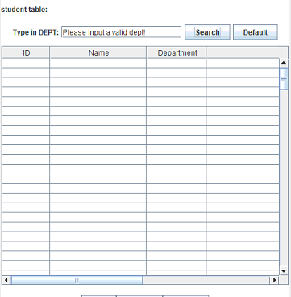

- To view all the students, press *Default Button*, and all the students will be listed in the table below.

**3.3.2 Modify Functions**

1. For both course and student tables, there are three buttons below. Each Button is corresponding to a data manipulation function.

2. For ADD function : *( Question (h) )*

Press *ADD Button.* A panel will pop out as follows:

* 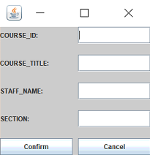You may enter the values in the corresponding text field.

After input all the values, press *Confirm Button*.

* If the input value is not valid, then the panel will present as follows:

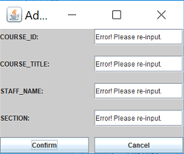Input value requirement:

COURSE_ID: String length <= 6

COURSE_TITLE: String length <= 100

STAFF_NAME: String length <= 100

SECTION: String length <= 3

GENDER: String length<=6

BIRTHDATE: String length<=10

3. For MODIFY function : *( Question (i) )*

- Select a table cell first, then press the *MODIFY Button*.

Then a hint will pop out as follows:

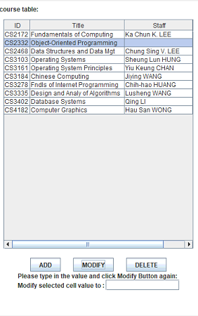

* As the hint instructed, you may input a value in the text field and press the MODIFY Button again.
* 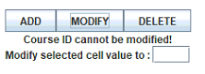If you select course ID or student ID, which is the key attributes of these two tables, then the hint will show:
* If the input new value is not valid, the hint will give corresponding prompt. Valid input requirement is given above.

4. For DELETE Function : *( Question (j) )*

- Select a row, then press the *DELETE Button.*

- If Deleted successfully, a prompt will pop up as follows:

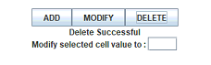

- If no row is selected, then the prompt will show :

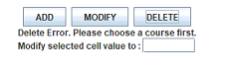

**3.3.3 Grade Functions** *( Question (k) )*

1. Search the grade for a student

- Type in the student ID as the instruction text shows :



- If a invalid student ID is typed, then the prompt will show as:



- Type in a valid student ID and press the *Details Button*.

Then a panel will pop out:

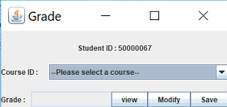

2. View and modify the grade for selected student

- Select a course from the combo box. The combo box contains all the course that the student has registered.

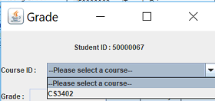 - Press the View Button to see the grade for this student for this course:

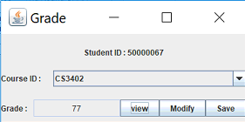

- Press *Modify Button* to modify the grade.

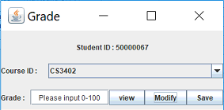

- Input a number between 0-100 as instructed, and press the *Save Button*.

- If the input number is not valid :

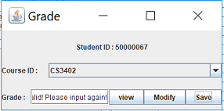

**3.3.4 List Top5 Functions**

1. Press the top 5 buttons as follows:

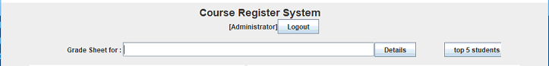

Then a new window will pop out as follows :

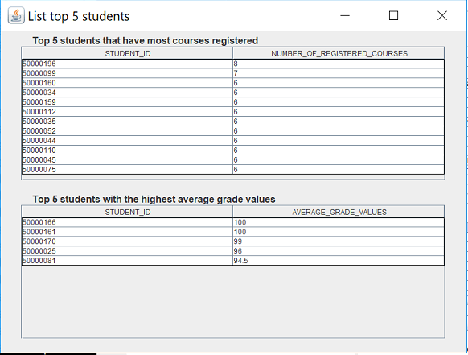

2.

*( Question (l) )*

*( Question (m) )*